Expository Writing-Class Activity
Problem Solution Essays
Name: | Juhayra Khan | Student ID: | 25I-0922 | Sec: | BCS-2F
Work on the Problem Solution App designed. Take screenshots for each step and add in the spaces given.
Step 1
1a. Your Topic + Describe the Problem
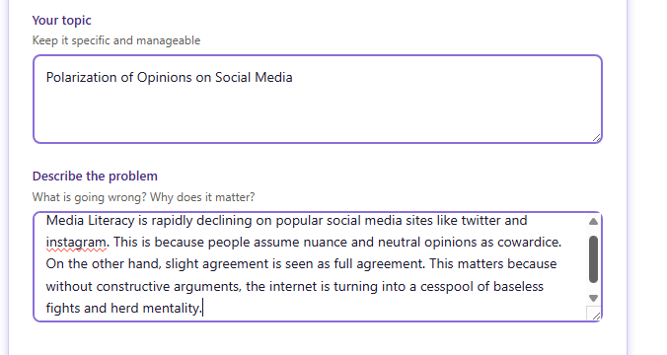

1b. AI Feedback Provided
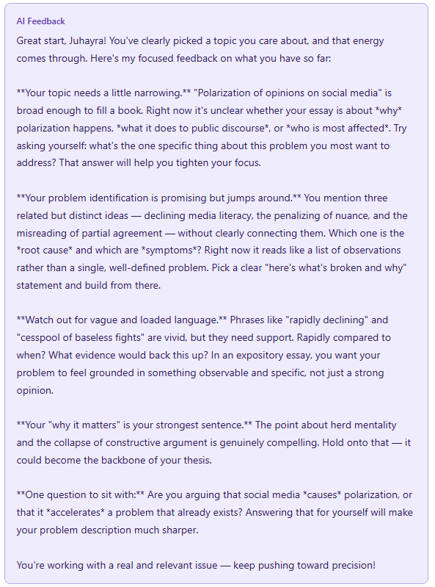
1c. Updated Topic & Problem After AI Feedback

Step 2- Thesis Builder
2a. Thesis
2b. AI feedback
2c. Improved Thesis after AI Feedback

Step 3- Exploring the Problem
3a. Body Paragraph 1- Problem
3b. AI Feedback Provided
3c. Improved Body Paragraph 1 after AI Feedback Incorporated
Step 4: Solution 1
4a. Body Paragraph 2
4b. AI Feedback Provided
4c. Improved Body Paragraph 2 after AI Feedback Incorporated

Step 5: Solution 2
5a. Body Paragraph 3
5b. AI Feedback Provided
5c. Improved Body Paragraph 3 after AI Feedback Incorporated

Step 6: Conclusion
6a. Conclusion
6b. AI Feedback Provided

Step 7: Reflection
7a. Which step did you find most challenging and why?
7b. Did breaking the essay into steps change how you approached writing? How?
Yes, because it made writing feel less o
7c. Describe one piece of AI feedback you found useful. How did you use it to improve your writing?
7d. Were there moments where you felt the AI feedback missed something important? What was missing?
7e. What are the limits of AI feedback for an essay like this?
7f. If you could improve one thing about how the tool guided you, what would it be?

